Introduction to HTML/CSS

Ques:1. How are inline and block elements different from each other?
Answer:
Inline vs block elements
Big difference is that inline elements do not start on new line and block element always begin on the new line. Inline elements are <button>, <textarea>, <input> etc. And block level elements are <div>, <p> etc. Block level elements are used to develop the large structure of the web apllication and inline level elements used for shorter structure.

Ques:2. Explain the difference between visibility:hidden and display:none?
Answer:
Visiblity:hidden always occupy the space of the tag even hidden on the page.

Display:none does not occupy any space of the tag on the page.

Ques:3. Explain the clear and float properties?

Answer: Clear property is a property which is used after the float property. Float property as the name suggest it provides the floating facility to the html tag and content. clear property specifies what elements can float beside the cleared element and on which side.it has the values left, right, both and float also has the values life, right etc.

Syntax: float:left | right | none and clear:left | right | both

Ques:4. explain difference between absolute, relative,fixed and static?
Answer: Position property define the positioning of the html element. We can position the html by using this property. There are total 5 position values like absolute, relative, fixed, static and sticky.

absolute: it always positioned to its near relative anchestor.
Syntax: position:absolute;

relative:relative is positioned relative to its normal position.
Syntax: position:relative;

fixed: as name says fixed means fixed to its position even we scroll the page. It always position relative to the viewport.
Syntax: position:fixed;

static: by default all html element are position static. If any html tag is defined by static property value it is always positioned according to the flow of the page.
Syntax: position:static;

Ques:5. Write the HTML code to create a table in which there are 4 columns( ID , Employee Name, Designation, Department) and at least 6 rows. Also do some styling to it?
Answer:

table.html
<!DOCTYPE html>
<html lang="en">
<head>
<meta charset="UTF-8">
<meta name="viewport" content="width=device-width, initial-scale=1.0">
<link rel="stylesheet" type="text/css" href="/Stylesheet/tablestyle.css">
<title>Table</title>
</head>
<body>
<table>
<tr>
<th>ID</th>
<th>Employee Name</th>
<th>Designation</th>
<th>Department</th>
</tr>
<tr>
<td>123</td>
<td>Vijay kumar</td>
<td>trainee</td>
<td>.net</td>
</tr>

<tr>
<td>121</td>
<td>Naveen verma</td>
<td>trainee</td>
<td>Android</td>
</tr>

<tr>
<td>135</td>
<td>Vishesh kapoor</td>
<td>trainee</td>
<td>Jvm</td>
</tr>

<tr>
<td>145</td>
<td>Neha goel</td>
<td>software engineer</td>
<td>flutter</td>
</tr>

<tr>
<td>191</td>
<td>Hena Dialani</td>
<td>senior software</td>
<td>python</td>
</tr>

<tr>
<td>181</td>
<td>Abhishek srivastava</td>
<td>trainee</td>
<td>front end</td>
</tr>
</table>
</body>
</html>

tablestyle.css
*{
margin:0px;
padding:0px;
}
table{
border-collapse: collapse;
width: 900px;
margin: auto;
margin-top: 40px;
color:grey;
padding: 10px;
}
th{
padding-top: 12px;
padding-bottom: 12px;
text-align: left;
background-color: #3CBC9C;
color: white;
}
td,th{
padding:10px;
border: grey 1px solid;
}
tr{
border: white 1px solid;
}
tr:hover{
background-color: grey;
color:white;
}

OUTPUT:
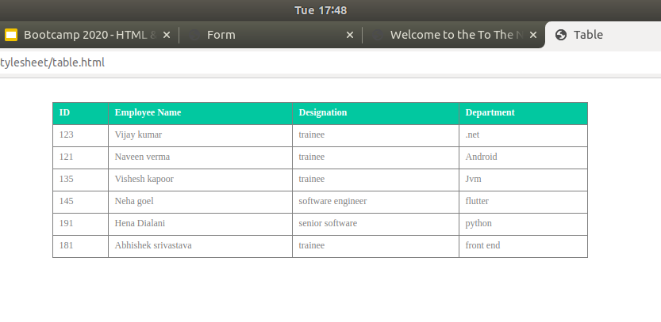

Ques:6.Why do we use meta tags?
Answer: Meta we know that metadata is the data about the data. Similary meta tag is a tag which define the page content. Meta tag provide the facility by which we can insert the keywords for the search engine optimization because as we know that every search engine read every website and look out the distinct keywrods. For example Google search engine has its own search crawler. Which crawl every website. Any give rating of every website. And show them on the top of the searches. Meta tag always comes in content and value.

Ques:7.Explain box model?
Answer: Box model is a box which wraps around every html elements. Box model Consist the margin , padding, borders and content. Below is the picture of the box model of the table.
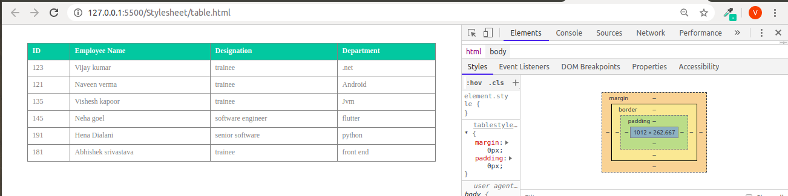

Ques:8. What are the different types of CSS Selectors?
Answer:
There are five selectors in css.
Id, class, group element, universal.
ID: id provides us to target the html element uniquely it help us to identify the html element uniquely. When we have to give the design to a particular element of html.
Class: provides us the facility to give same design on the multiple html elements

Ques:9.Define Doctype?
Answer: Doctype is not a html tag it is the first thing which is written on the top of the html file it tells the browser what is the version of the html or html page written in.
Syntax: <!Doctype html>

Ques:10. Explain 5 HTML5 semantic tags?
Answer: <header>, <footer>, <Section> , <aside> and <nav>
<header>: it specify the header of the document.browser understand the header starts from the header tag.
<footer>: it specify the footer of the document.browser understand the footer starts from the footer tag. It is always present on the bottom of the page.
<nav>: navigation html 5 tag shows the navigation of the websites.
<section>: this tag is used to section the html content.
<aside>: aside tag specify the content into side the content which is not part of the flow.

Ques:11. Create HTML for web-page.jpg (check resources, highest weightage for answers) ?
Answer:
index.html
<!DOCTYPE html>
<html>
<meta name="=description" content="Detail of the website">
<title>Welcome to the To The NEw </title>
<link rel="stylesheet" type="text/css" href="/Stylesheet/stylesheet.css">
</html>
<body id="bd">
<!--main container start from here-->
<div id="main-container">
<div id="header">
<div id="ttn">
<h1>To the New</h1>
<nav id="nav-container">
<ul class="flex-nav">
<li class="li-content"><a href="#">Text Link</a></li>
<li class="li-content"><a href="#">Text Link</a></li>
<li class="li-content"><a href="#">Text Link</a></li>
<li class="li-content"><a href="#">Text Link</a></li>
<li class="li-content"><a href="#">Text Link</a></li>
</ul>
</nav>
</div>
</div>
<div id="middle-content">
<div id="image-container">
<p>960 x 360px</p>
</div>
<section id="content">
<p>VESTIBULUMACCUMSAN EGESTIBULUUEU JUSTO CONVALLIS AUGUE ESTAS AENEAN ELIT INTESQUESED. FACILISPEDE ESTIBULUM NULLA ORNA NISL VELIT ELIT AC ALIQUAT NON TINCIDUNT NAMJUSTO CRAS URNA</p>
</section>
<section id="heading2">
<h2>Latest From The Gallery</h2>
</section>
<section id="cards-container">
<div class="cards">
<div class="div-card-item">
<p>215 x 315px</p>
</div>
<p id="caption">Image Caption Here</p>
</div>

<div class="cards">
<div class="div-card-item">
<p>215 x 315px</p>
</div>
<p id="caption">Image Caption Here</p>
</div>

<div class="cards">
<div class="div-card-item">
<p>215 x 315px</p>
</div>
<p id="caption">Image Caption Here</p>
</div>

<div class="cards">
<div class="div-card-item">
<p>215 x 315px</p>
</div>
<p id="caption">Image Caption Here</p>
</div>
</section>
</div>
<footer id="footer">
<section id="footer-container">
<div id="footer-left">Copyright &#169; 2009-2017-All Rights Reserved-To the new</div>
<div id="footer-right">Web layout by To the new</div>
</section>
</footer>
</div>
<!--main container ends here-->
</body>
</html>

stylesheet.css

*{
padding:0px;
margin:0px;
}
#bd{

background-color: #353535;
}

#main-container{
width: 1200px;
margin: auto;

}
#header{
background-color: #323232;
}
#ttn{
width: 960px;
margin:auto;
padding: 10px;
color:#908882;

}
h1{
font-size:26px;
}
#nav-container{
background-color: #222222;
}
.flex-nav{
display: flex;
}
ul{
list-style-type: none;
}
a{
text-decoration: none;
color:#908882;
}

.li-content{
margin: 10px 10px 10px 0px;
padding: 10px ;
}

#middle-content{
width: auto;
padding-top:20px;
padding-bottom: 20px;
box-sizing: border-box;
background-color: #ffffff;
}
#image-container{
width:960px;
height: 360px;
display: flex;
justify-content: center;
background-color: #323232;
align-items: center;
font-size: 26px;
color:#ffffff;
margin:auto;
}
#content{
width:960px;
background-color: #EDEDED;
color:#979797;
margin:auto;
box-sizing: border-box;
margin-top: 20px;
padding:10px;
}
#heading2{
width: 960px;
box-sizing: border-box;
margin: auto;
margin-top: 20px;
color:#ADADAD;
padding-bottom: 15px;
border-bottom:#ADADAD 1px solid ;
}

/*footer starts*/
#footer{
box-sizing: border-box;
background-color: #222222;
}
#cards-container{
width: 960px;
margin:auto;
margin-top: 10px;
display: flex;
justify-content: space-between;
}
.cards{
width:215px;
padding:5px;
border:#ADADAD 1px solid ;
}
.div-card-item{
height: 315px;
background-color: #323232;
justify-content: center;
color: #ffffff;
display: flex;
align-items: center;
}
#caption{
font-size: 16px ;
padding: 15px;
text-align: center;
background-color: #EEEEEE;
color: #A2A2A2;
}

#footer-container{
width: 960px;
height: 80px;
margin: auto;
display: flex;
justify-content: space-between;
align-items: center;
color: #ffffff;
}

OUTPUT:
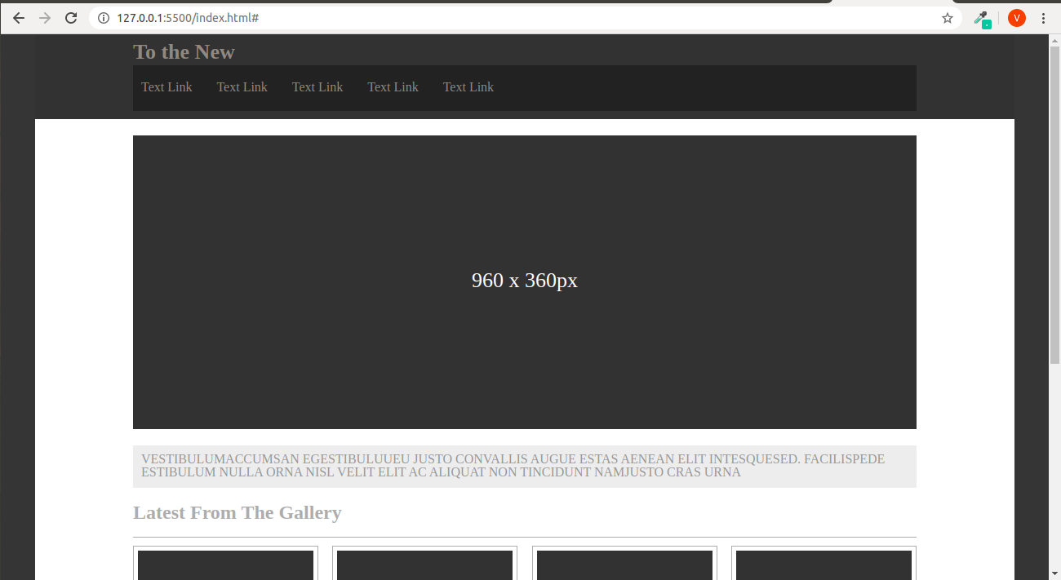

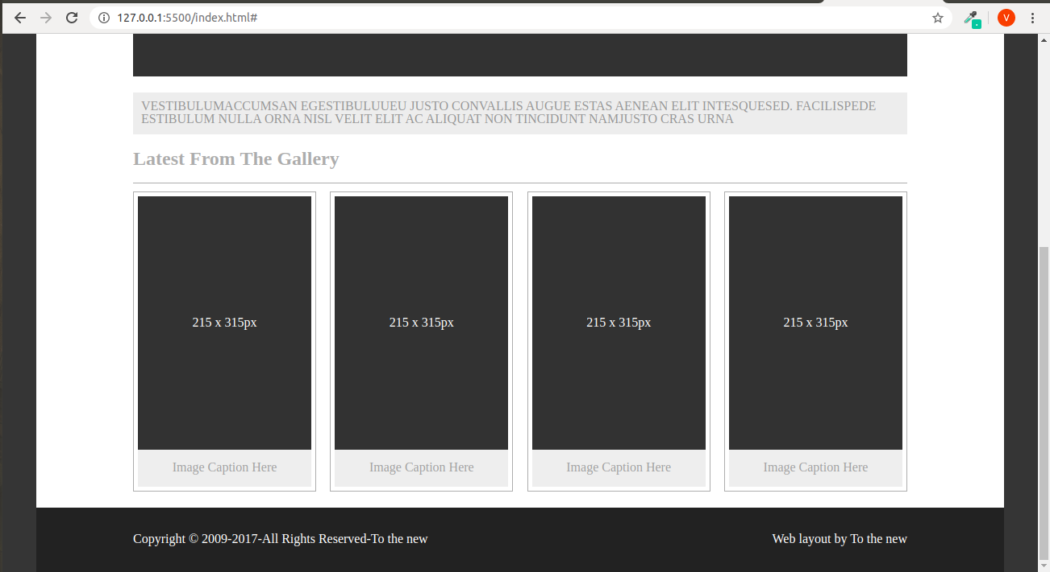

Ques:12. Create HTML for form.png (check resources, highest weightage for answers)?
Answer:
form.html

<!DOCTYPE html>
<html lang="en">
<head>
<meta charset="UTF-8">
<meta name="viewport" content="width=device-width, initial-scale=1.0">
<link rel="stylesheet" type="text/css" href="/Stylesheet/formstyle.css">
<title>Form</title>
</head>
<body>
<header id="header">
<a href="#" id="brand">TO THE NEW </a>
<div id="header-right">
<a href="#">Home</a>
<a href="#">Quick Help</a>
</div>
</header>
<div id="main-form-container">
<div id="forms-heading">
<h1>Bug Report</h1>
</div>
<form action="#" id="form">
<label for="title">Title:*</label><br>
<input type="text" name="title" id="title"><br>
<label for="desc">Description:*</label><br>
<textarea name="desc" id="desc"></textarea><br>
<label for="os">Operation System:</label>
<br>
<select name="os" >
<option value="windowxp">Window Xp</option>
<option value="ubuntu">ubuntu</option>
<option value="Mac">Mac</option>
<option value="win10">Window 10</option>
</select><br>
<label for="product">Product:*</label>
<br>
<select name="product" >
<option value="Formoid">Formoid</option>
<option value="office">office</option>
</select><br>
<label for="ver">Version:*</label><br>
<input type="text" name=version id="ver"><br>
<label for="type">License:</label><br>
<input type="radio" name="License" value="free" id="free"/><label for="free">Free</label>
<input type="radio" name="License" value="business" id="business"/><label for="free">Business</label>
<br><br>
<label for="severity">Severity:</label>
<br>
<select name="severity">
<option value="critical">Critical</option>
<option value="moderate">moderate</option>
<option value="low">Low</option>
</select><br>
<label for="attachement">Attachments:</label><br>
<!-- <label for="upload-file">No File Selected</label>-->
<ul id="file">
<li id="no-file">No file Selected</li>
<li id="upload"><label id="choosebtn">Choose file<input type="file"></label></li>
</ul>
</form>
<div id="forms-bottom">
<input type="submit" value="Send">
</div>
</div>
</body>
</html>

formstyle.css

*{
padding: 0px;
margin: 0px;
}
#header{
padding :30px;
border-bottom: #EDEDED 1px solid;
margin-bottom: 20px;
}
#brand{
float: left;
font-size: 22px;
}
#header-right{
float: right;
}
h1{
font-family: Verdana,sans-serif;
color: #ffffff;
padding:30px 30px;
}
a{
text-decoration: none;
font-family: Verdana,sans-serif;
color:#36A3A4;
}
#main-form-container{
width:500px;
margin:auto;
margin-bottom: 20px;
border: 2px solid #BDC3C7;
border-radius: 5px;
}
#forms-heading{
box-sizing: border-box;
height: 80px;
background-color: #BCC3CA;
}
#forms-bottom{
height: 90px;
background-color: #E2E4E6;
}

#form-footer{
width: auto;
height: 80px;
margin-top: 10px;
background-color: #EDEFF1;
box-sizing: border-box;
}
#form{
margin: 10px 0px 10px 0px;
padding:0px 20px 0px 20px;
color: #7D7D7D;
font-family: Verdana,sans-serif;
}
input[type="text"]{
width: 100%;
padding: 10px 10px;
margin: 8px 0;
display: inline-block;
border: 1px solid #ccc;
border-radius: 4px;
box-sizing: border-box;
}
textarea{
width: 100%;
height: 80px;
border: 1px solid #ccc;
border-radius: 4px;
}
select{
width: 100%;
padding: 10px 10px;
margin: 8px 0;
display: inline-block;
border: 1px solid #3CBC9C;
background-color: #3CBC9C;
border-radius: 4px;
color: #ffffff;
font-weight: bold;
box-sizing: border-box;
}
input[type="submit"]{
padding:10px 10px;
color: #ffffff;
font-weight: bold;
margin:25px 25px;
border-radius: 4px;
background-color: #3CBC9C;
float: right;
vertical-align:middle ;
border-style: none;
}
#business{
margin-left: 150px;
}
#ver{
width: 150px;
}
/*
input[type="file"]{
width: 100%;
padding: 10px 10px;
margin: 8px 0;
display: inline-block;
border: 1px solid red;
border-radius: 4px;
box-sizing: border-box;
}*/
input[type="file"]{
display: none;
}
#choosebtn{
padding: 10px;
background: grey;
display: table;
color: #fff;
}
#file{
display: inline-block;
border: grey 1px solid;
border-radius: 5px;
}
#file>li{
list-style-type: none;
float: left;
}
#no-file{
padding: 10px 235px 10px 5px;}

OUTPUT:

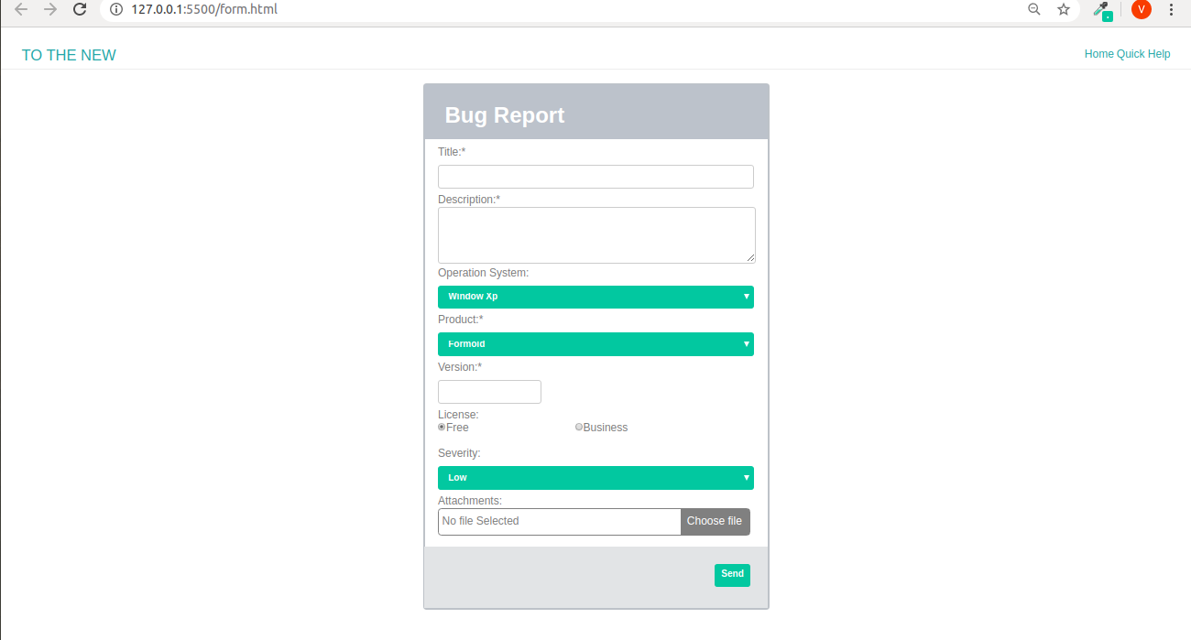

Note: 50% of marks are for last 2 exercises of creating html pages.

Submitted by
(VIJAY KUMAR)

